**Project Planning Phase**

**Project Planning Template (Product Backlog, Sprint Planning, Stories, Story points)**

|  |  |
| --- | --- |
| Date | 27-10-2022 |
| Team ID | PNT2022TMID44982 |
| Project name | Personal Assistant For Seniors Who Are Self Reliant |

**Product Backlog, Sprint Schedule, and Estimation**

|  |  |  |  |  |  |  |
| --- | --- | --- | --- | --- | --- | --- |
| **Sprint** | **Functional**  **Requiremen t**  **(Epic)** | **User**  **Story**  **Numb**  **er** | **User Story / Task** | **Story points** | **Priority** | **Team**  **Members** |
| Sprint 1 | Set Alarm | USN-1 | As a user, I can set an  alarm to alerting a  medicine through medicine remainder system | 10 | High | RANJITH KUAMR  R |
| Sprint 1 |  | USN-2 | As a user, I can Activate and Deactivate the alarm | 10 | High | ABISHEK G |
| Sprint 2 | Notification | USN-3 | As a user once I can the set the alarm then I gets the notification | 10 | High | AABID  KALEEM  A |
| Sprint 2 |  | USN-4 | As a user, If I requires this system then a  notification will be sent into his device. | 10 | High | DHINAKA  RAN S |
| Sprint 3 | Medication Detail | USN-5 | As a user, I have multiple medications each day, I can put each pill in the box for the corresponding day. | 10 | High | ABISHEK G |

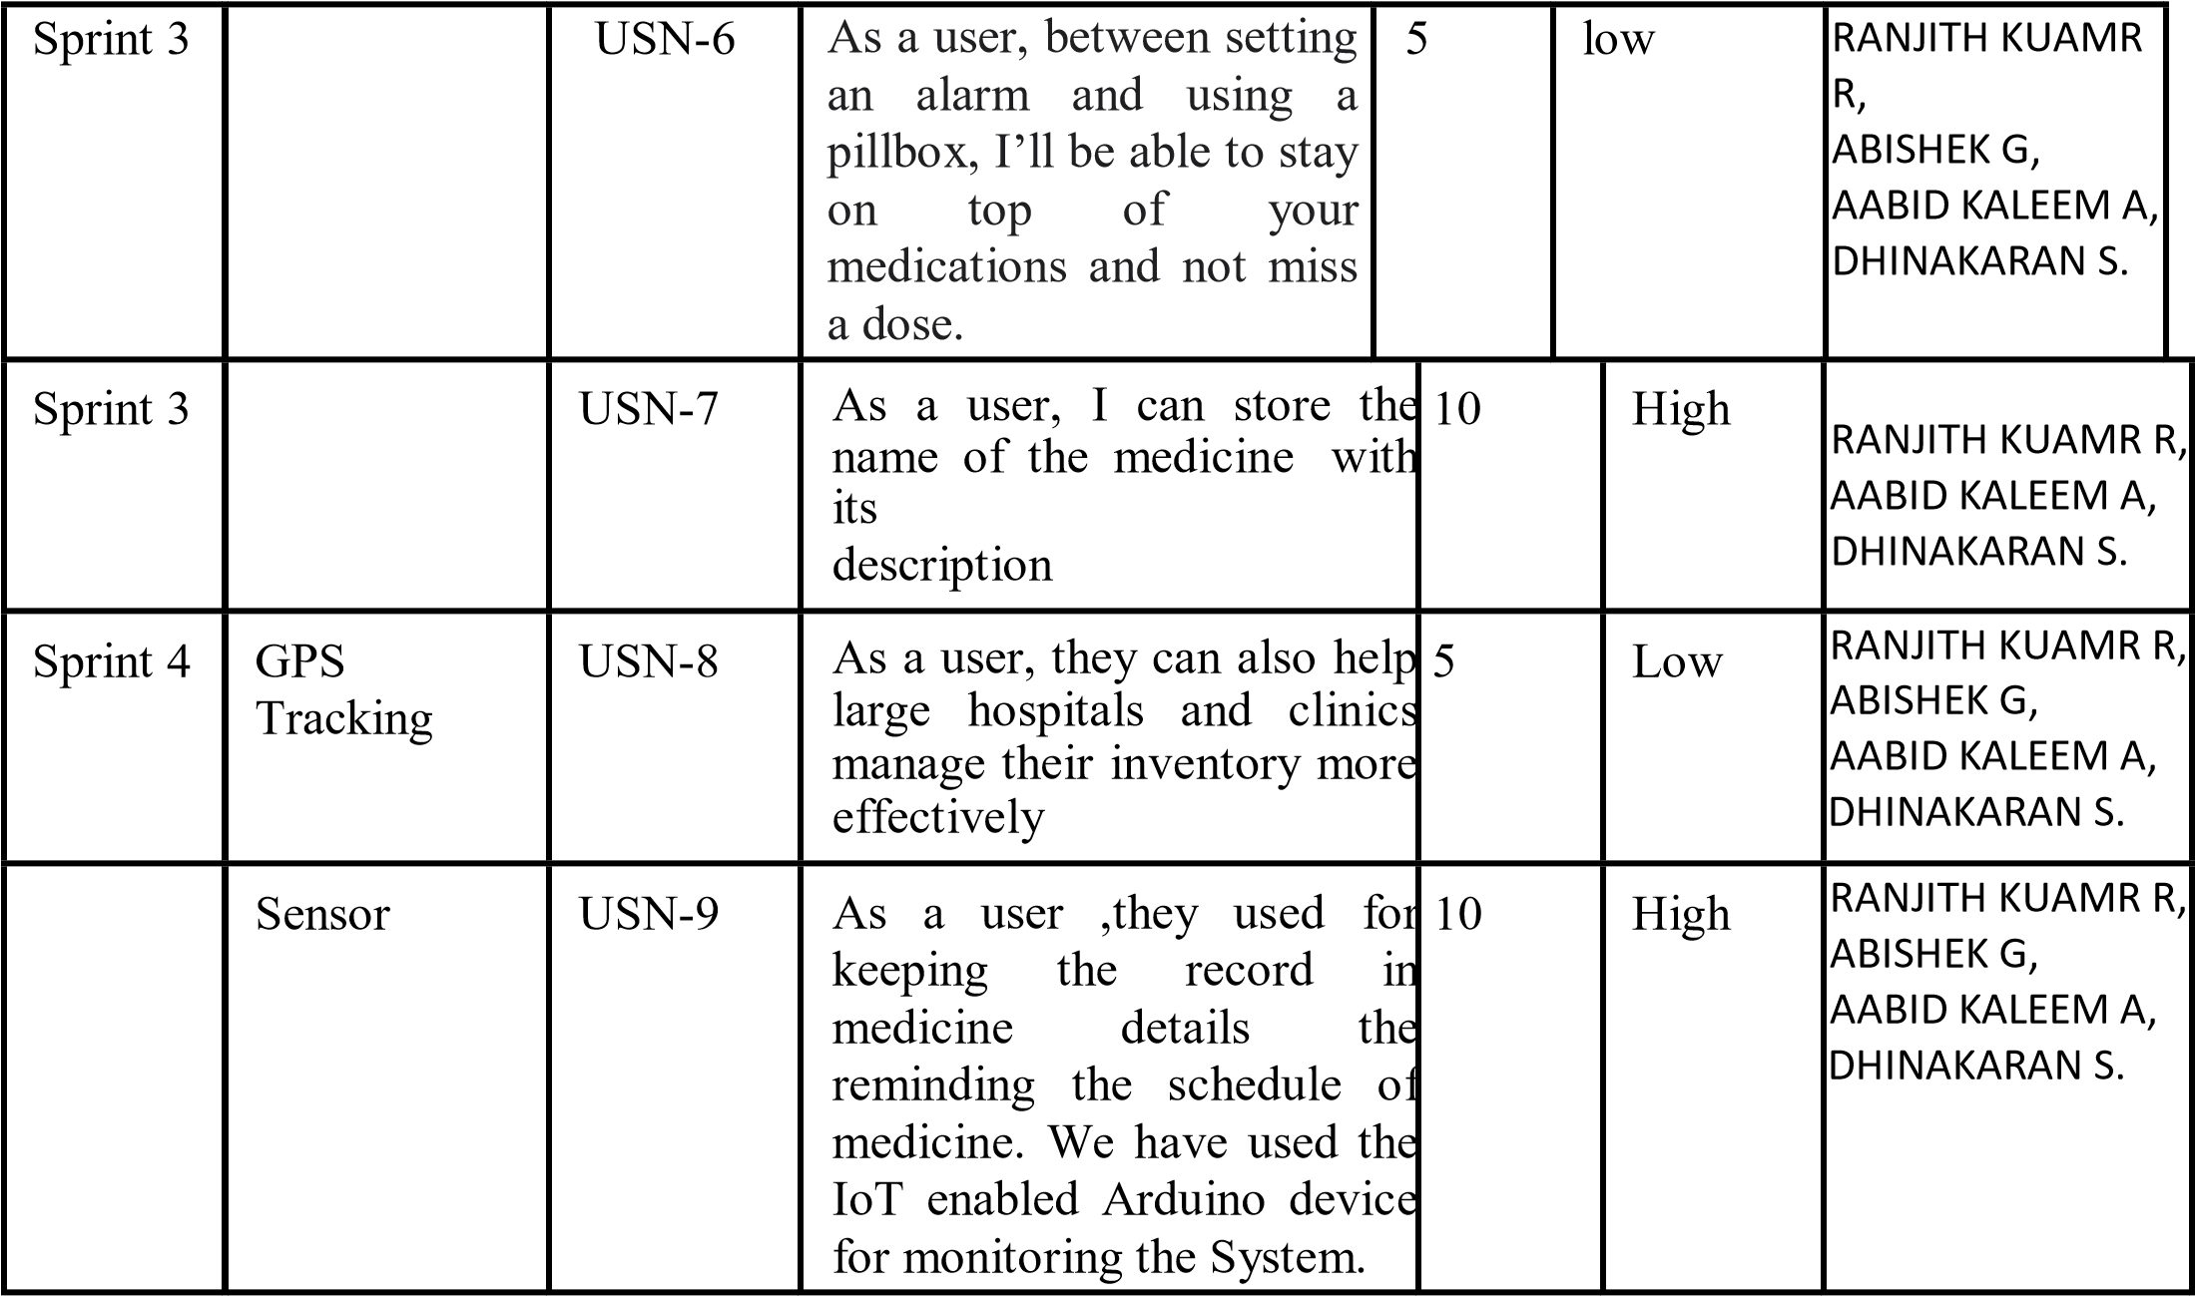

**Project Tracker, Velocity & Burndown Chart:**

|  |  |  |  |  |  |  |
| --- | --- | --- | --- | --- | --- | --- |
| **Sprint** | **Total**  **Story**  **Points** | **Duration** | **Sprint Start Date** | **Sprint End**  **Date**  **(Planned)** | **Story Points**  **Completed (as on**  **Planned End Date)** | **Sprint Release Date (Actual)** |
| Sprint 1 | 20 | 8 days | 29-10-2022 | 5-11-2022 | 20 | 4-11-2022 |
| Sprint 2 | 10 | 8 days | 7-11-2022 | 14-11-2022 | 10 | 13-11-2022 |
| Sprint 3 | 20 | 8 days | 16-11-2022 | 23-11-2022 | 20 | 23-11-2022 |
| Sprint 4 | 10 | 8 days | 23-11-2022 | 30-11-2022 | 10 | 30-11-2022 |

**Velocity:** . Let’s calculate the team’s average velocity (AV) per iteration unit (story points per day).

# AV = Velocity / Sprint Duration

**= 20 / 8**

**= 2.5**

**AV =10 / 8**

**= 1.25**

**Burndown Chart :**



**25**

300

**20**

250

200

**15**

150

**10**

100

**5**

50

**0**

0

**Start**

**Week**

**1**

**Week**

**2**

Days

**Week**

**3**

**Week 4**

Remaining

Effort

Ideal

Burndown